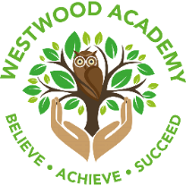
THE HARMONY TRUST
Westwood Academy

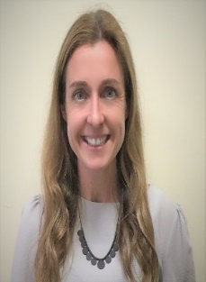
Miss Wimperis says … Next week, we will be raising money for Children In Need, on Friday 18th November. The children will be selling books and cakes in the playground at the end of the day.

Miss Wimperis’ news
This week some of our Children’s Mental Health Ambassadors have started their work with Oldham Primary Health Champions Programme. The Health Champions programme aims to share the latest information regarding current, local and national health and wellbeing agendas, which the children will learn about and share back in school. The focus of this week’s session was Healthy ME. The children took part in lots of activities to help them keep healthy. These included sports activities, team building, keeping warm and learning about free activities that are available in their local area.

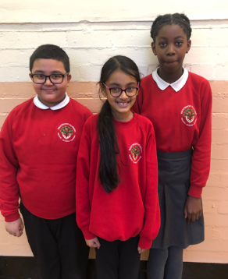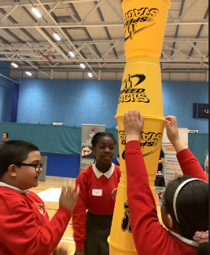

Next week will be … Anti-Bullying week! Remember to wear odd socks on Monday.
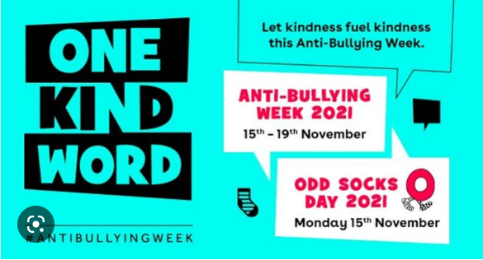
Word of the week  Remembrance – to honour and  remember those who lost their lives to war. | Attendance Champions!  Well done Year 6 with 98%

What has each class been learning about this week?

Nursery- This week in Nursery, we have been reading the story ‘Mum and Dad make me laugh’. We used the book to help us to learn all about patterns. We have also been exploring Bonfire Night and worked together to make a pretend bonfire and painted giant firework pictures.

Reception- This week in Reception, we have been learning all about the celebration Bonfire Night. In Literacy we read a story called ‘Sparks in the Sky’ and we wrote our own sentences about fireworks. In Maths, we have been exploring numbers 1, 2 and 3.

Year 1- This week in English, we have been writing a setting description based on The Great Fire of London. In Maths, we have been introduced subtracting and how to count back using a number line.

Year 2- This week, Year 2 have been writing facts about the moon! In Maths, we have been learning to add and subtract 2-digit numbers. We have loved History this week because we made a human timeline! In Science, we made fantastic habitats using shoe boxes!

Year 3- This week in English, we have been writing a diary from the perspective of The Stone Age Boy. In maths, We have been working really hard to learn estimation and inverse and have just started a new block on multiplication and division.

Year 4- This week in English, we have been writing a diary for CJs day. In Maths, we have been exploring multiplication and division and using our known facts to help us!

Year 5- This week in English, we have been writing a narrative retell about The Pirate Queen. In Maths, we have been learning about square and cube numbers.

Year 6- This week in English, we have re-created Flossie’s War Diary, which has included lots of creative doddles and pictures! In maths, we have been excelling at adding and subtracting fractions.

Stars of the week
Year group | Stars of the week | Reason for the award
Nursery | Sarrinah  Umar | For creating fantastic patterns in mathematics.  For being an amazing builder when role playing Bonfire Night.
Reception | Noor  Rayyan | For great effort in Phonics and spotting rhyming words.  For creating a beautiful poppy for Remembrance Day.
Year 1 | Zayd  Faiza | For using his phonics independently when writing his setting description.  For fantastic throwing and catching the ball during PE!
Year 2 | Arhaam  Roshni | For his marvellous maths work this week!  For her marvellous moon writing!
Year 3 | All of Year 3! | For amazing participation and enthusiasm on our trip to Castleshaw! Make sure you look out our gallery on the blog!
Year 4 | Tawheed  Sophia | For exploring with the art materials to bleed the colours!  For being a super scientist and exploring circuits!
Year 5 | Nuhin  Ayana | For designing a beautiful Tudor rose in DT.  For showing resilience in Maths, trying her best and asking lots of questions.
Year 6 | Markus  Amina | For amazing effort in his math’s lessons  For being an excellent role model

